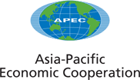
___________________________________________________________________________
2007/SOM3012attB3rev1
Agenda Item: V

Conduct Principles for Public Officials

Purpose: Consideration

Submitted by: ACT Chair

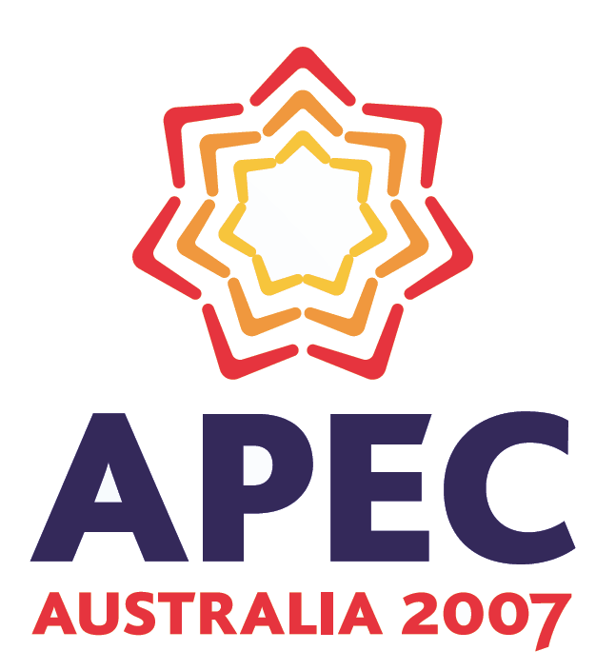 | Third Senior Officials’ Meeting  Cairns, Australia  3 July 2007

APEC Conduct Principles for Public Officials

At the 14th Economic Leaders’ meeting held in Hanoi in 2006, leaders reaffirmed their high commitment to fight corruption and usher in a community of integrity. Similarly, in 2006, APEC Ministers stressed the importance of preventive measures and integrity systems in the fight against corruption and urged member economies to adopt and implement codes or norms of conduct that are aligned, as appropriate, with the UN Convention Against Corruption.

That Convention requires parties to promote integrity, honesty and responsibility among
their public officials. In particular parties are to endeavor to apply codes or standards of conduct for the correct, honorable and proper performance of public functions.

Taking into consideration the UN International Code of Conduct for Public Officials, and further informed by the UN Convention Against Corruption, the APEC Anti- Corruption Task Force recommends member economies establish, enhance or review to ensure that their legislative and/or administrative codes or standards of conduct for all public officials, as defined by national and international law, are based upon the following principles:

1. A public official shall respect and adhere to the Constitution or basic law and the laws and legal norms of his or her economy including applicable codes of conduct.

2. A public official shall use his or her public position only in furtherance of the public interest and not for purposes of gaining an unwarranted advantage for him- or herself or for others.

3. A public official shall not solicit or receive, directly or indirectly, any gift, favor or benefit in exchange for official action or inaction, or that may influence or appear to influence the exercise of his or her functions, duties or judgment.

4. A public official shall protect and conserve public monies, property and services and shall use these public resources for only authorized purposes.

5. A public official shall disclose information that is available to him or her by virtue of official position in accordance with the economy’s applicable transparency norms, but should use such information only for authorized purposes.

6. A public official shall perform his or her duties with efficiency, integrity, fairness and impartiality, including when performing a legitimate political or other activity.

7. A public official shall avoid taking any official actions that will affect his or her personal or family financial interests, or acquire any position or function or have any financial, commercial, fiduciary or other comparable interest that conflicts or may reasonably appear to conflict with his or her office, functions and duties.

8. A public official shall respect and utilize established measures and systems designed to facilitate reporting acts of corruption to appropriate authorities and shall, if within his or her official responsibilities, hold others properly accountable for their actions.

9. A public official shall adhere to all requirements for reporting to appropriate authorities his or her outside activities, employment, financial investments and liabilities, assets and gifts or benefits.

10. A public official shall comply with measures established by law or administrative policies in order that after leaving an official position he or she will not take improper advantage of that previous office.

Consistent with the UNCAC and the APEC Santiago Course of Action, APEC economies shall, according to their capacities, afford one another the widest measure of technical assistance in helping to develop these legal norms and codes or standards of conduct. Member economies shall make every effort to provide public officials with the education, training and counseling necessary for their understanding and appreciation of these principles as well as the various legal norms and codes or standards of conduct that implement these principles. To help create mutual expectations between officials and the public, member economies should publicize the legal norms and codes or standards of conduct. Member economies shall also institute appropriate measures aimed at rectifying the conduct of individuals who fail to abide by and implement these principles.

